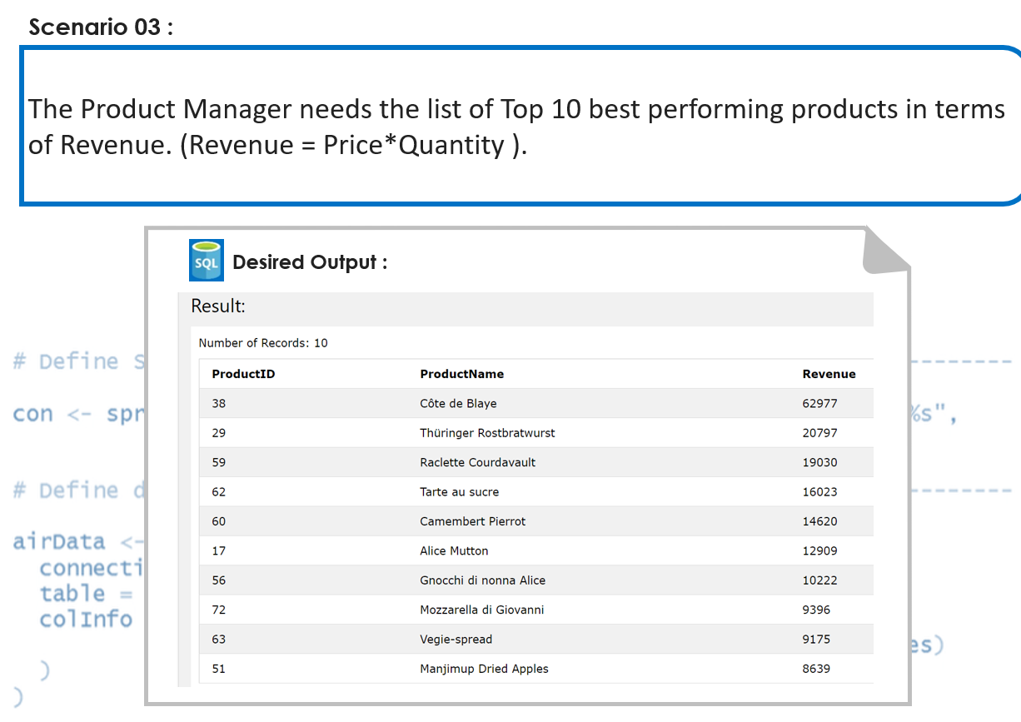

* select (P.ProductID), (P.ProductName), (P.Price\*O.Quantity) as Revenue from Products P
* JOIN OrderDetails O ON O.ProductID = P.ProductID
* GROUP BY P.ProductName, P.ProductID
* Order By (P.Price\*O.Quantity) DESC
* Limit 10

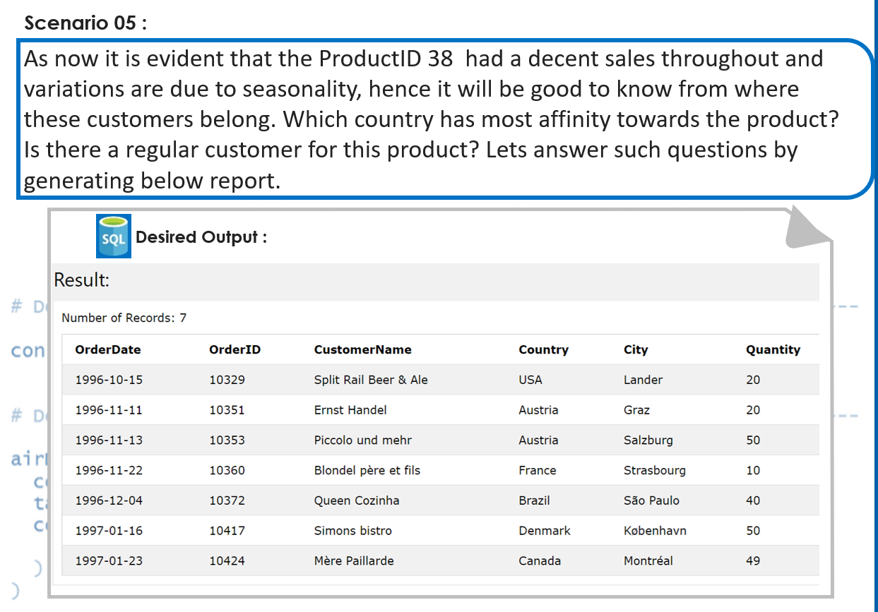

* SELECT O.OrderDate, O.OrderID, C.CustomerName, C.Country, C.City, Quantity
* FROM Orders O
* JOIN Customers C ON C.CustomerID = O.CustomerID
* JOIN OrderDetails Od ON Od.OrderID = O.OrderID

